**Sample Group Project Selections**

**Here are some nice examples of how to integrate graphics effectively into your written report. The first example has graphics that take up much of a page (hence I would not count it in the page total); the second one is a more subtle inclusion in a page of text.**

Sample I

**Snapchat**

**. . .**

Snapchat has two main duties in regards to Snap Map: *Non-Injury* and *Veracity*. Snapchat has a duty to protect its users, but by broadcasting the exact locations of its offenses, they end up with cases such as a Missouri mother sending nude photos with her teenage daughter and a middle school teacher sending explicit images to students, both of which have shown up in court. Interestingly, Snapchat rarely files lawsuits against violators of the terms of service, nor takes action against them by restricting access to the service. The Code of Ethics states on line 2e that employees of Snapchat should “report users who violate the Terms of Service.” Regardless, Snapchat does not regulate the service as well as they ought. This clearly violates the duty of *harm-prevention* and *non-injury*, to the point of providing a method of injury without consequences. There are methods of determining whether images are pornographic, or whether users violate the Terms of Service in other ways, and Snapchat should invest in these preventative measures in order to enforce the guidelines they set in place.

# **Likely Future Ethical Issues**

Now that Snapchat is a publicly traded company, future ethical issues are likely to arise from the push/pull struggle between *investors* who wish to see value added to the company and *customers* who wish for privacy, quality, features, etc. There are two main ways in which Snapchat is likely expand: (1) by moving into new markets such as different age groups or foreign nations, and (2) by increasing the depth of Snapchat's service to garner more revenue from current customers.

When it comes to increasing the depth service, we already have seen the multiple problems brought about by introducing SnapCash and Snap Map. Snapchat has been tight lipped about their future plans, but such plans should be considered with ethical issues in mind to avoid ethical problems that could have been prevented. For instance, Snapchat specifically states its platform is meant for kids 13 and older, so future features should be made for and marketed for that age group in spite of the adult only content Snapchat has been known for in the past.

Expanding into foreign markets is a common method to add value to a company, as is done by many social tech corps such as google, facebook, twitter, etc. However much of the world has internet censorship of its citizens.

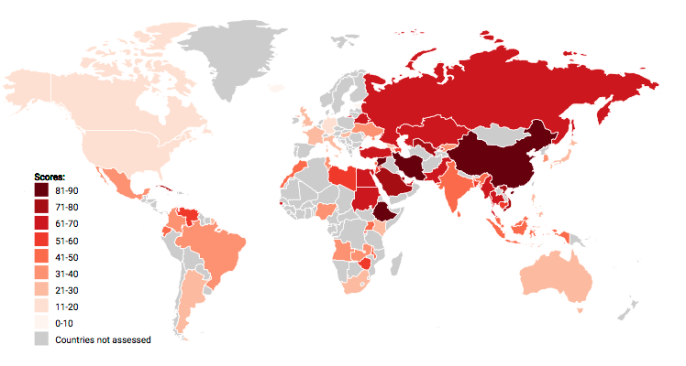

The map above taken from FreedomOnTheNet.org ranks countries internet censorship, a higher score denotes more censorship. For instance, the UK has laws against “hate speech” while China has laws against even reading or discussing information about certain “sensitive” historical events like the Tiananmen Square protest. The ethicality of such laws is discussion for another time, but Snapchat has the dilemma that if certain forms of speech are not allowed (even in private), then all users must have all of their data analyzed and/or stored. To expand into these censored markets and obey this censorship would break the duty of veracity due to Snapchats code of ethics and promise that people can communicate privately. They would also break the duty of no-harm because allowing the dissemination of such data puts at risk the freedom and in some cases lives of their customers. For instance, such data could be used to prosecute users for things that are crimes in those countries but not in the United States. Storing such user data can also cause harm to users if such data is hacked, breached, or

……………………………………………………………………………………………………

**Sample II**:

